
TEST PLAN
EDUCATIONAL ASL GAME

July 29, 2026
JAKOB COX, YEABTSEGA TENA, TANJAI PLOYKAO
CMSC 495

TEST CASES

Feature: ASL Learning Generation
Objective: Verify 4 different ASLSign images and meanings are shown.
Preconiditions:
- database1 contains an array of 4 ASLSign’s. “A”,”B”,”C”, and “D” that are not unlocked.
- Unhandled input (Game Manager) TEST_ACTION calls Handle_Interact(“NEWSPAPER”)
TestSteps:
- Start game
- Press the “Play” button on the main menu
- Press shift+T
Expected Results: The screen should display 4 ASL signs to the player. Both their meaning and image should be shown
Actual Result:
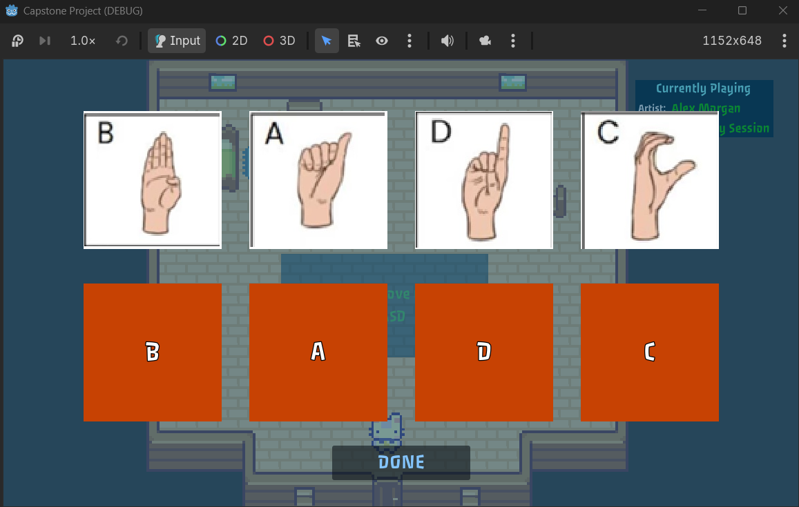
Status: PASS
Feature: ASL Quiz Generation
Objective: Verify 4 different ASLSign images and meanings are shown and quiz cycles through different questions and question types.
Preconditions:
- database1 contains an array of 4 ASLSign’s. “A”,”B”,”C”, and “D” that are unlocked.
- Unhandled input (Game Manager) TEST_ACTION should set DataManager.quiz_tutorial_shown = true
- Unhandled input (Game Manager) TEST_ACTION calls Handle_Interact(“TREE1”)

TestSteps:
- Start game
- Press the “Play” button on the main menu
- Press shift+T
- Answer questions displayed on screen until no questions are displayed
Expected Results: The screen should display either an image prompt with 4 meanings or a meaning prompt with 4 images. The player should be able to click on one of the 4 answers and the quiz should present a new question. This should be done 4 times, since this is the size of generated by CreateASLQuiz.
Actual Result:
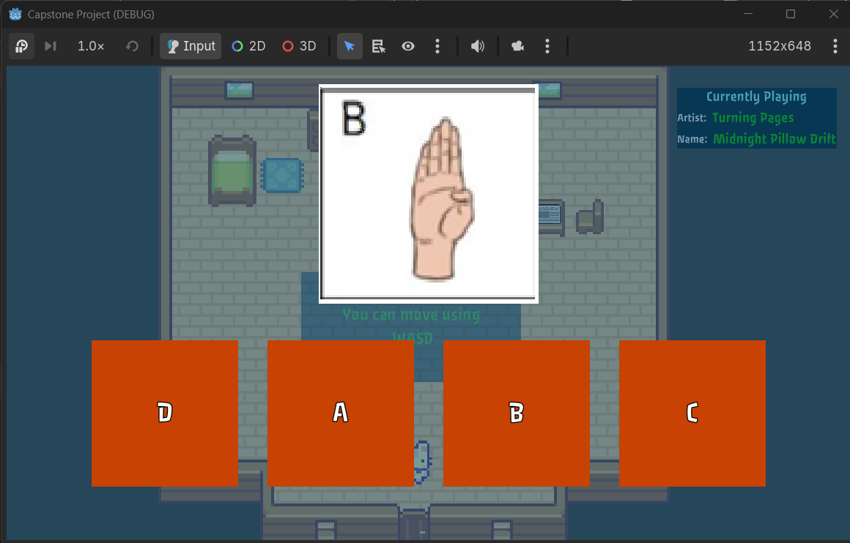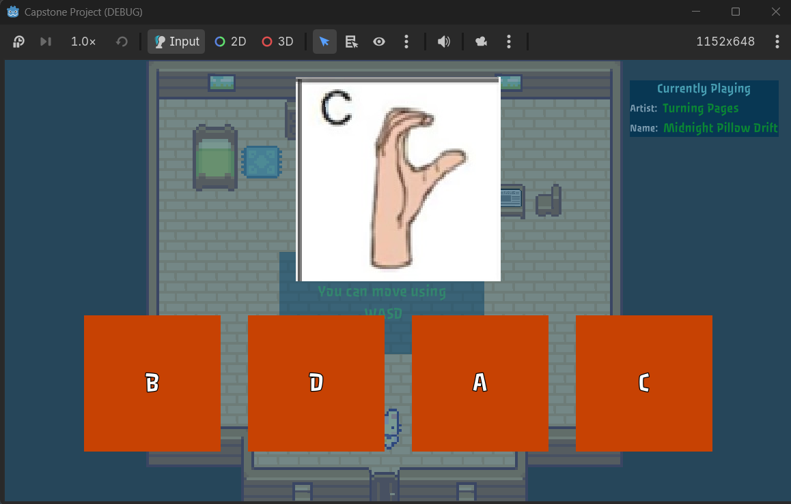
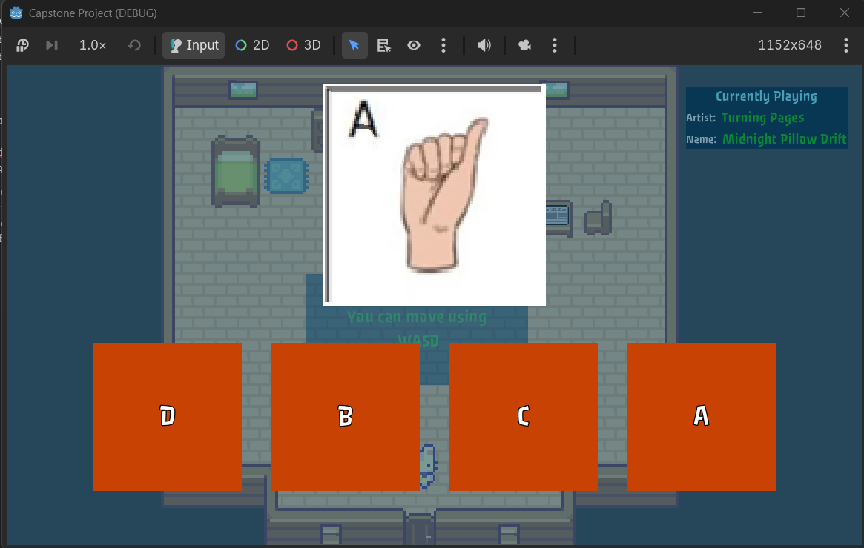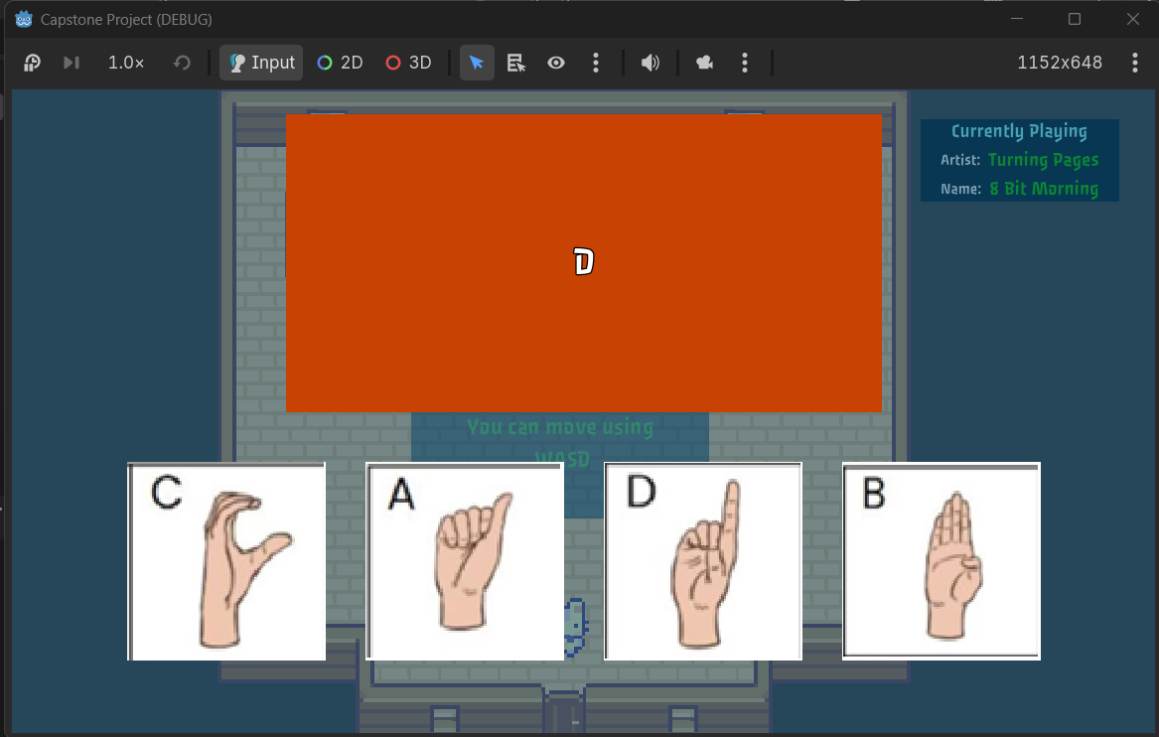

Status: pass

Feature: ASL Learning Generation
Objective: When ASLDatabase has less than 4 signs remaining until fully learned, ensure that the learning displayed only shows the remaining ASLSign/s.
Preconditions:
- database1 contains an array of 4 ASLSigns
- 3 ASLsigns should be not be unlocked by the player and one should be unlocked.
- Unhandled input (Game Manager) TEST_ACTION calls Handle_Interact(“NEWSPAPER”)
TestSteps:
- Start game
- Press the “Play” button on the main menu
- Press shift+T
Expected Results: The screen should display the remaining 3 ASLsigns to the player. Both their meaning and image should be shown
Actual Result:
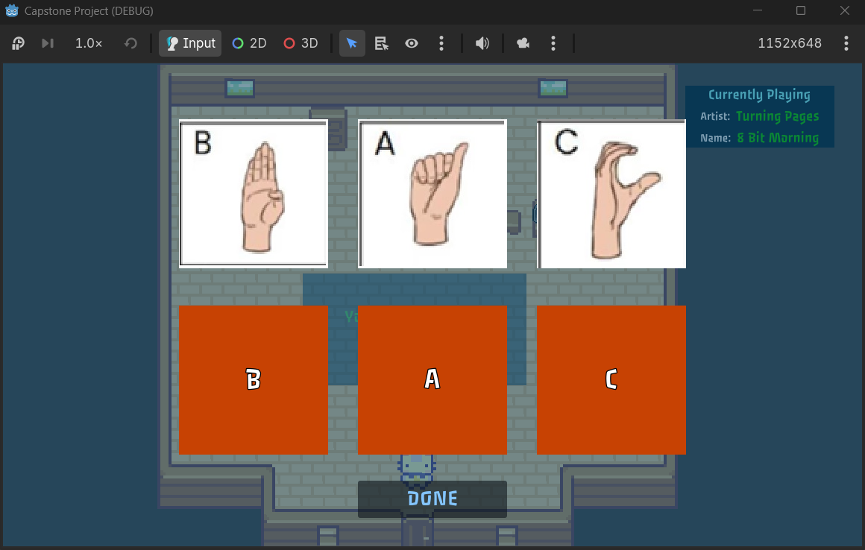

Status: pass

Feature: ASL Learning Generation
Objective: When all ASLSigns in a data base have been unlocked, the player should not be shown any signs of that difficulty level. If the player has grown the tree of that difficulty level fully the player should be shown
Preconditions:
- DB_1 is loaded with 4 signs all unlocked (A,B,C,D).
- DB_1 is should be set true
- TREE1 is fully grown
- database2 has at least 4 ASLSigns that are not unlocked
- Unhandled input (Game Manager) TEST_ACTION calls Handle_Interact(“NEWSPAPER”)
TestSteps:
- Open Game
- Press the “Play” button on the main menu
- Press Shift+T
Expected Results: The screen should display 4 ASL signs to the player. Both their meaning and image should be shown. All ASL Signs shown should come from databse2.
Actual Result:
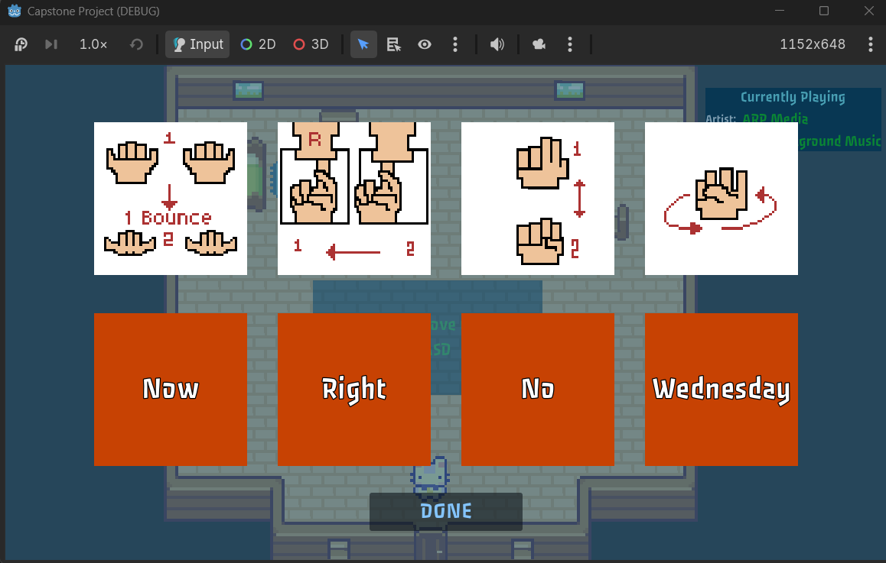
Status: pass

Feature: Player Movement
Objective: Test whether player is able to move Up, Down, Left, and Right.
Preconditions:
- Create a 2D Scene called Test.
- Character should be instantiated into Test scene.
TestSteps:
- Run Test scene (Not game_manager scene)
- Press W
- Press A
- Press S
- Press D
Expected Results: Player should move Up, Left, Down, and then Right.

Actual Result:
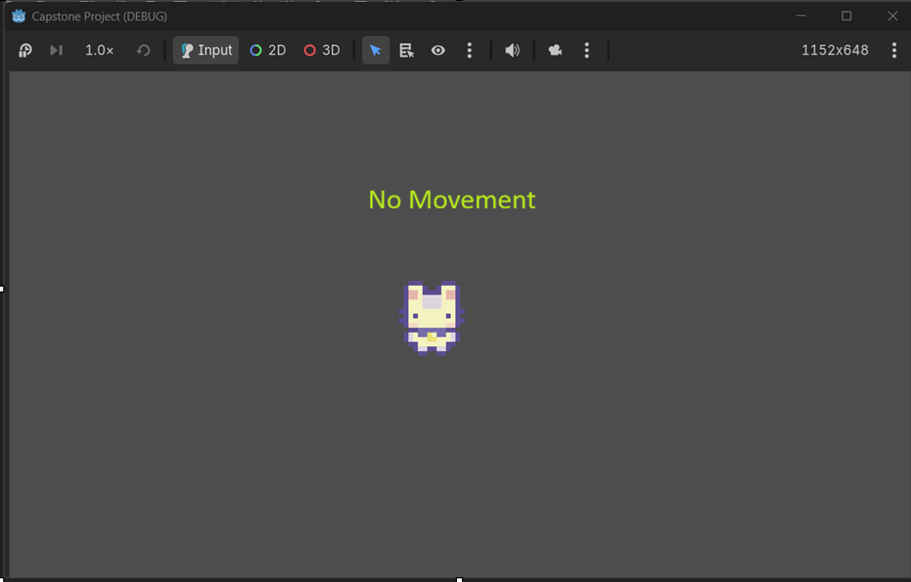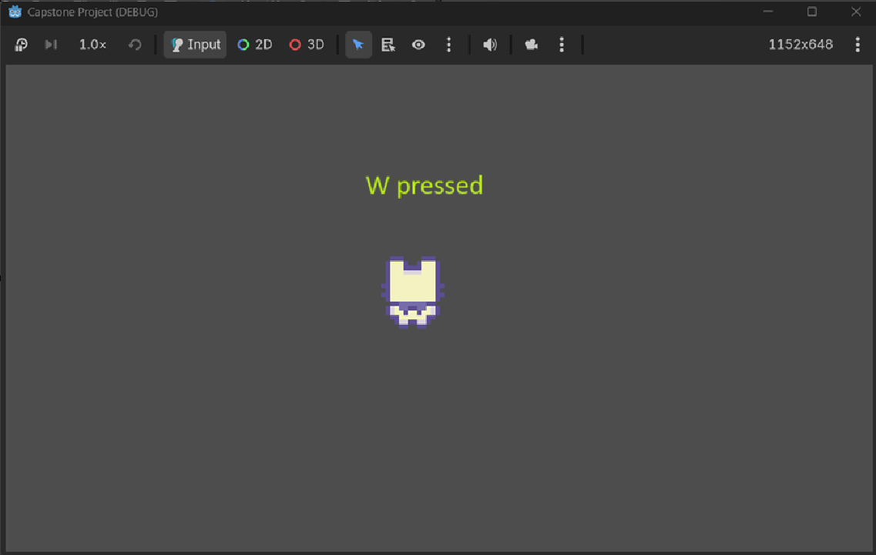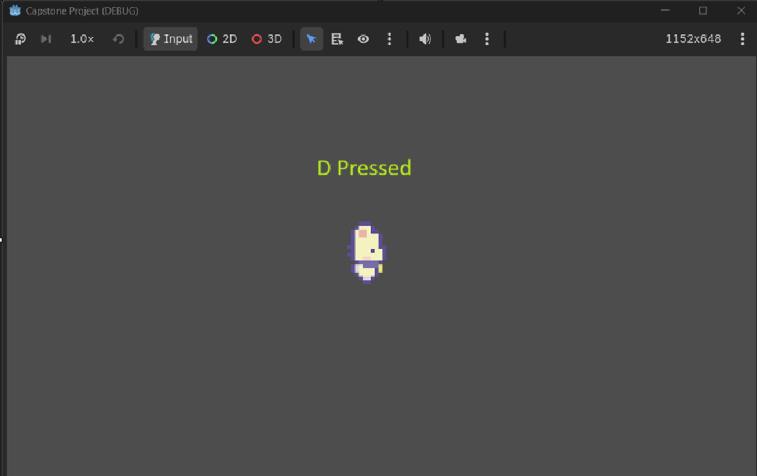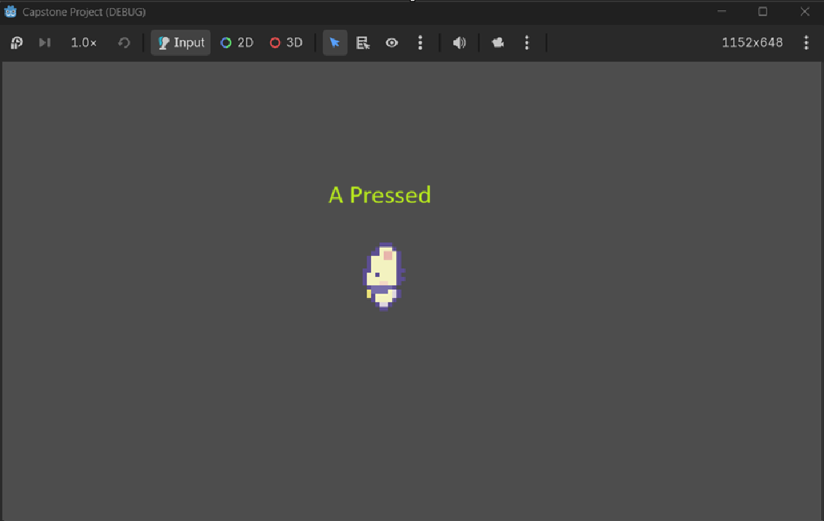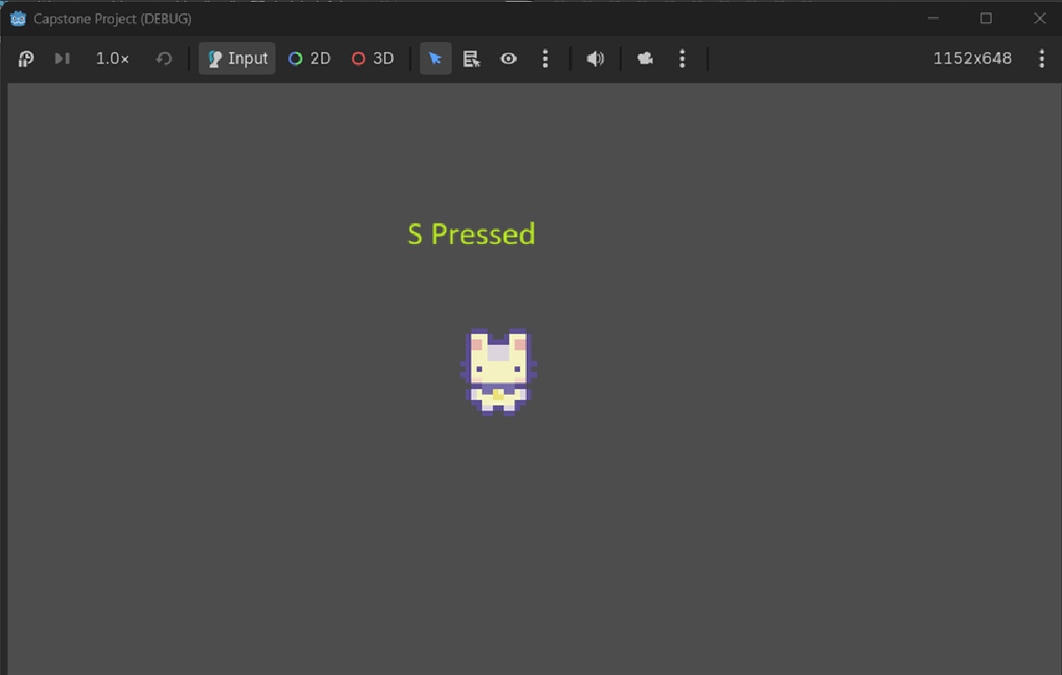
Status: Pass

Feature: Player Interaction
Objective: Test whether player is able to interact with newspaper.
Preconditions:
- Collision zones should be shown through debug mode
- database1 contains at least 4 ASLSigns (A,B,C,D) that are not unlocked.

TestSteps:
- Start Game
- Press the “Play” button on the main menu
- Move player into outer collision zone of newspaper
  - Using W,A,S,D
- Press E
Expected Results: An ASL Learning should start.

Actual Result:
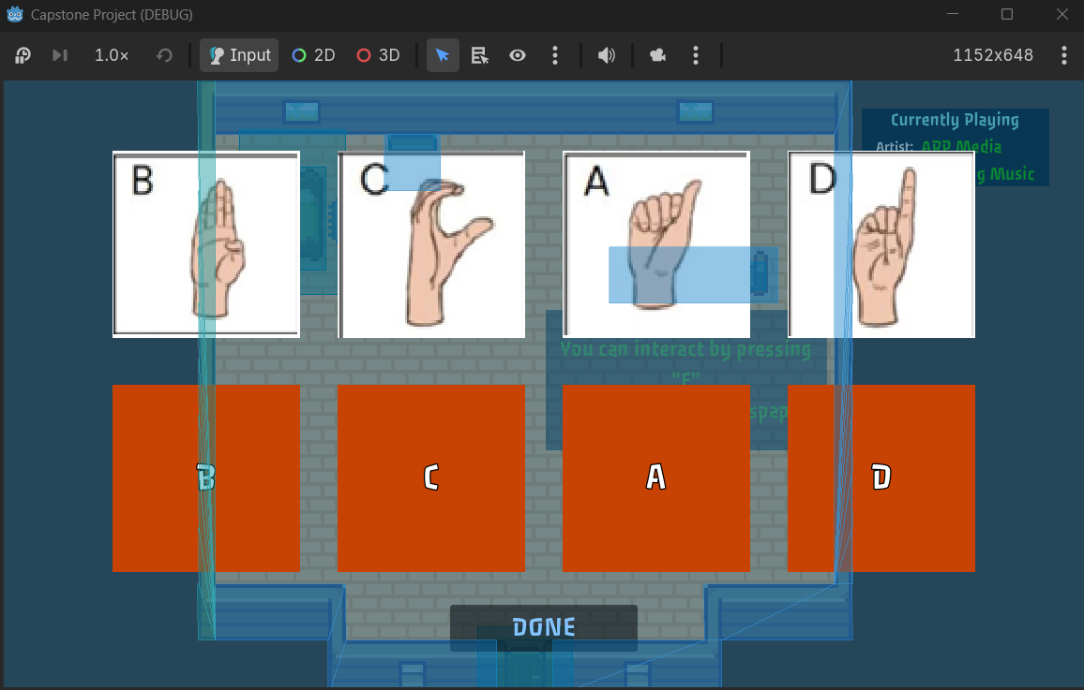

Status: Pass

Feature: Player Interaction
Objective: Test whether player is able to interact with TREE1
Preconditions:
- Collision zones should be shown through debug mode
- DB_1 contains at least 4 ASLSigns (A,B,C,D) that are not unlocked.
- _ready() function should set DataManager.quiz_tutorial_shown = true

TestSteps:
- Start Game
- Press the “Play” button on the main menu
- Move player int outer collision zone of Newspaper
  - Using W,A,S,D
- Press E
- Click “Done”
- Move player into door collision zone
- Move player into outer collision zone of Tree1
  - Using W,A,S,D
- Press E
- 4x: click on one of the 4 answers.
Expected Results: Player should see an ASL learning when interacting with the newspaper. When player walks to door the scene should transition to the farm. When the player interacts with the tree an ASL quiz should show.
Actual Result:
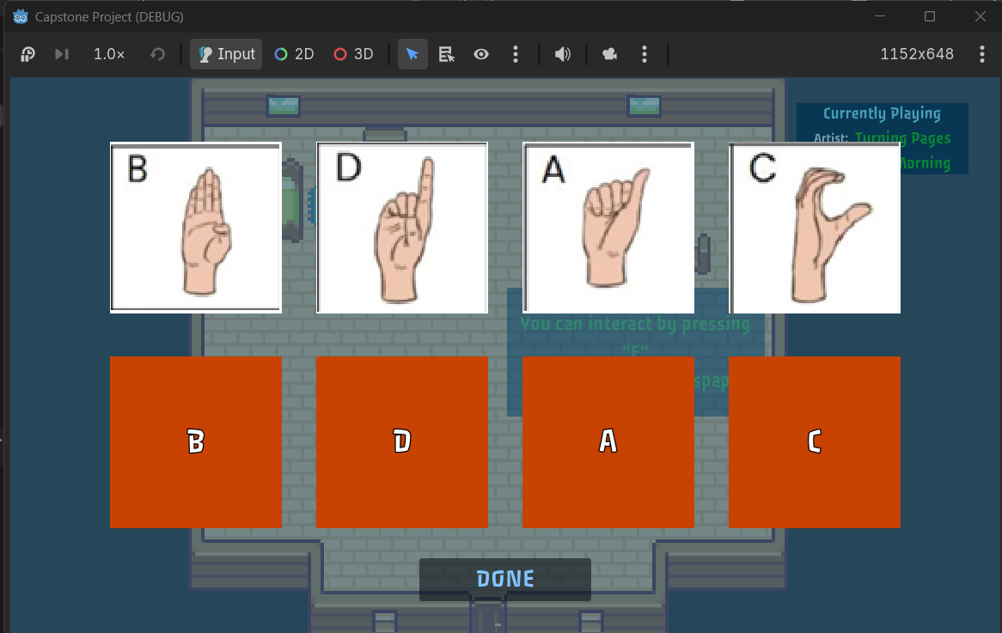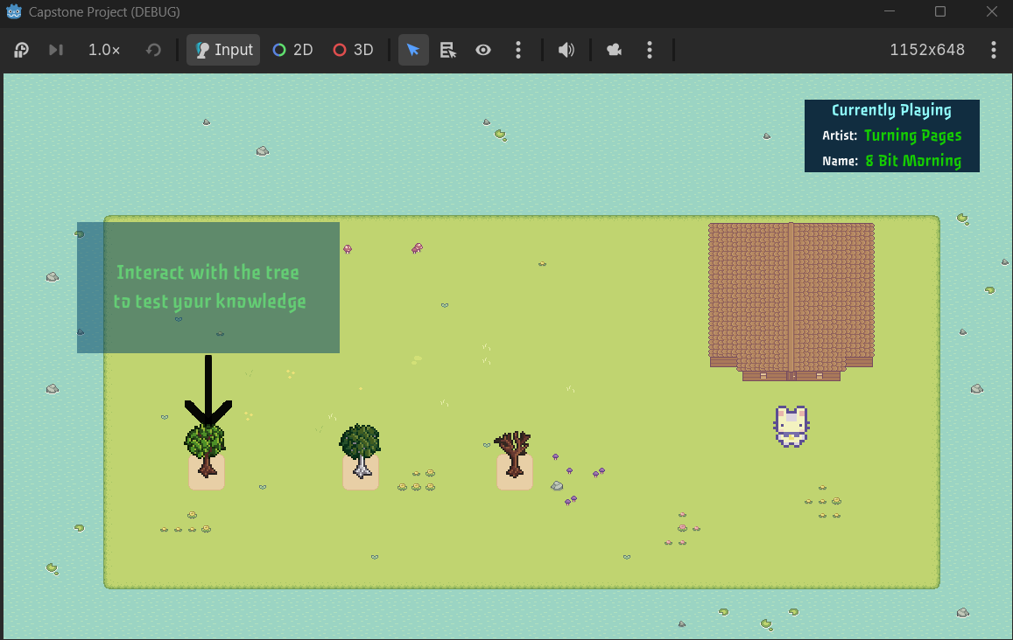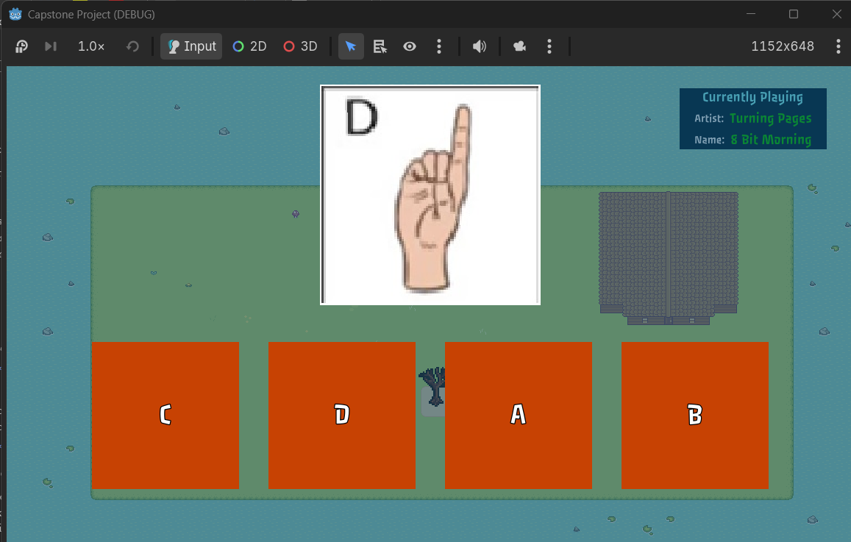

Status: Pass

Feature: Player Interaction
Objective: Test whether player is able to interact with Bed
Preconditions:
- Collision zones should be shown through debug mode
- DB_1 contains at least 4 ASLSigns (A,B,C,D) that are not unlocked.
- _ready() function should set DataManager.quiz_tutorial_shown = true

TestSteps:
- Start Game
- Press the “Play” button on the main menu
- Move player int outer collision zone of Newspaper
  - Using W,A,S,D
- Press E
- Click “Done”
- Move player into door collision zone
- Move player into outer collision zone of Tree1
  - Using W,A,S,D
- Press E
- 4x: click on one of the 4 answers.
- Move player into door collision zone of home
- Move player into bed collision zone.
- Press E

Expected Results: Player should see an ASL learning when interacting with the newspaper. When player walks to door in the home scene the scene should transition to the farm. When the player interacts with the tree an ASL quiz should show. When player walks to the door in the farm scene the scene should transition to home. When player interacts with bed the screen should begin to fade to black.

Actual Result:
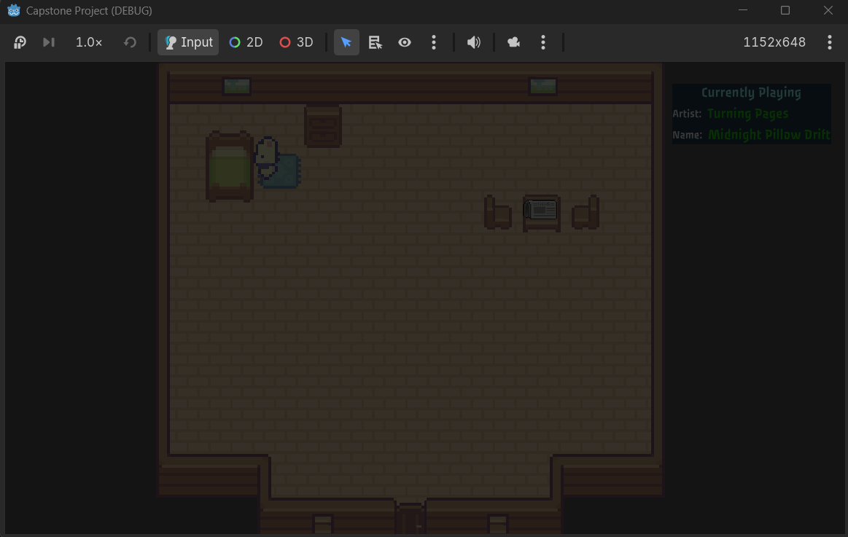
Status: Pass

Feature: Scene Transitions
Objective: Test whether player properly transitions from Home to Farm scene when character enters into home_to_farm collision zone.
Preconditions:
- Collision zones should be shown through debug mode
- database1 contains at least 4 ASLSigns (A,B,C,D) that are not unlocked.
TestSteps:
- Start Game
- Press the “Play” button on the main menu
- Move player int outer collision zone of Newspaper
  - Using W,A,S,D
- Press E
- Click “Done”
- Move player into door collision zone of home
Expected Results: Scene should transition from Home to Farm.

Actual Result:
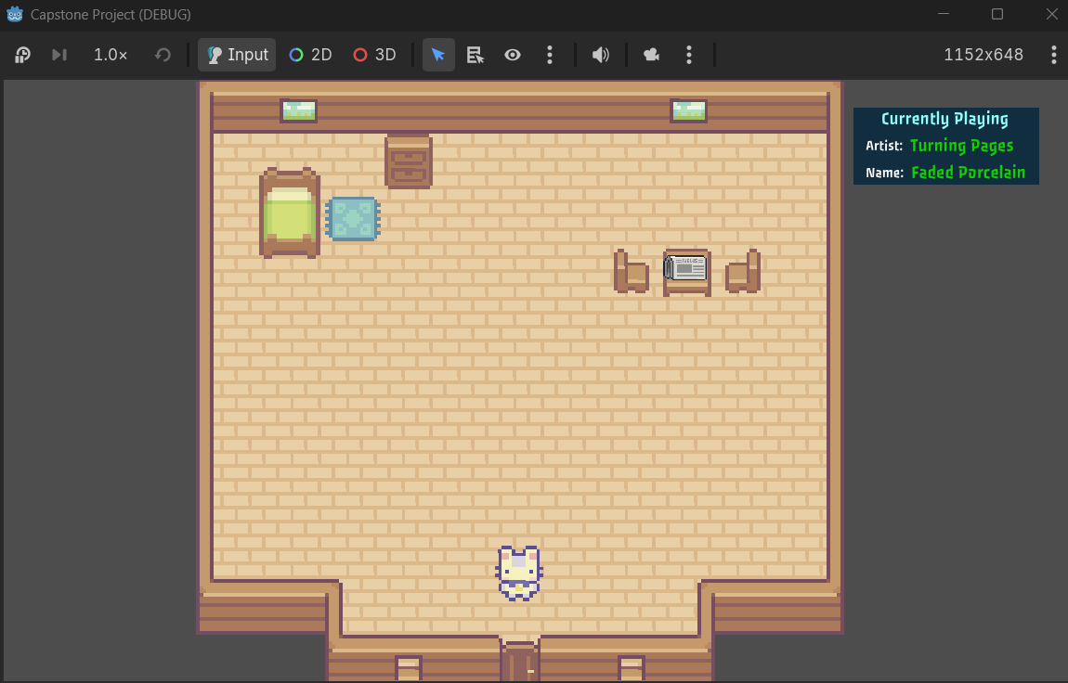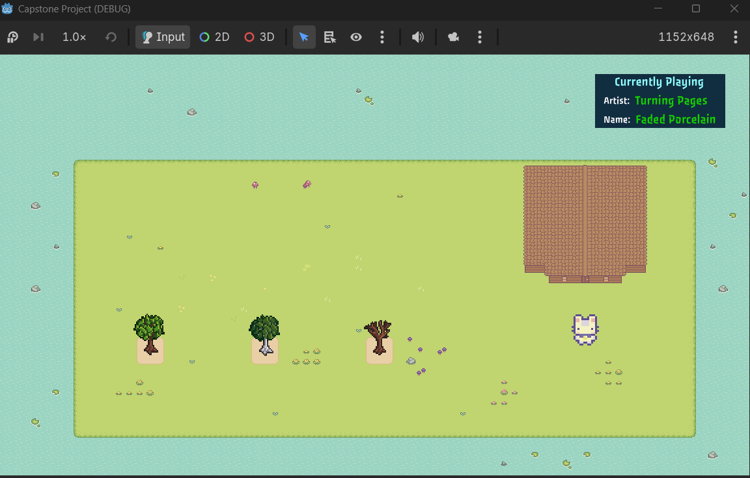
Status: Pass

Feature: Scene Transitions
Objective: Test whether player properly transitions from Farm to Home scene when character enters into farm_to_home collision zone.
Preconditions:
- Collision zones should be shown through debug mode
- DB_1 contains at least 4 ASLSigns (A,B,C,D) that are not unlocked.
TestSteps:
- Start Game
- Press the “Play” button on the main menu
- Move player int outer collision zone of Newspaper
  - Using W,A,S,D
- Press E
- Click “Done”
- Move player into door collision zone of home
- Move player into door collision zone of farm

Expected Results: Scene should transition from Farm to Home.

Actual Result:
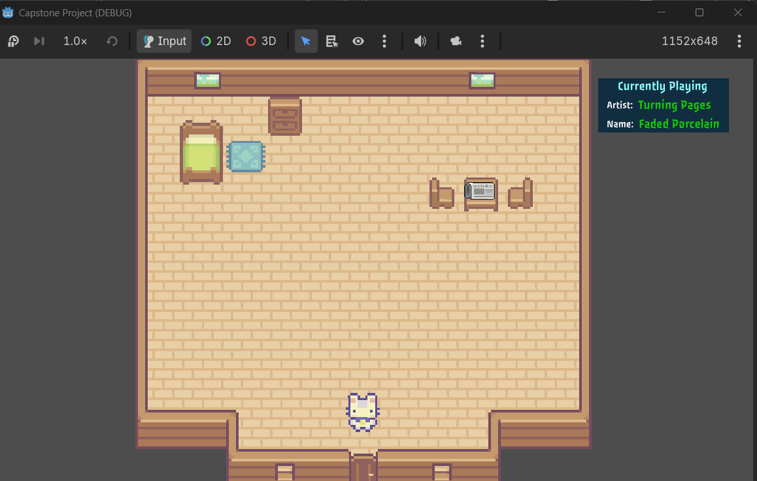

Status: Pass

Feature: Pause_UI
Objective: Test whether Pause_UI shows and pauses background when escape key is pressed.
Preconditions:
- None
TestSteps:
- Start Game
- Press the “Play” button on the main menu
- Press Escape on keyboard
- Attempt to move character (WASD)
- Press Escape on keyboard
- Attempt to move character (WASD)
Expected Results: Pause_UI should display and the character should be unable to move. Once Escape is pressed again, Pause_UI should be hidden and the character should be able to move.

Actual Result:
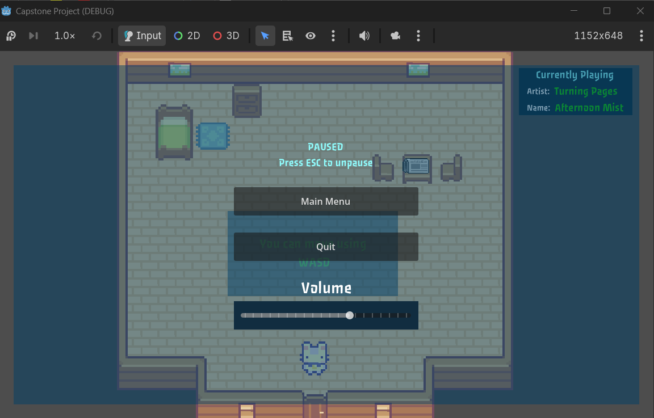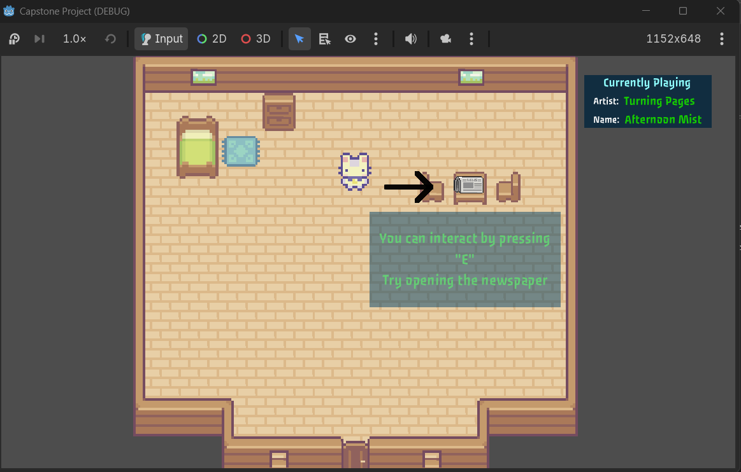
Status: Pass

Feature: Character Boundaries
Objective: Test whether character can leave the boundary of the home scene
Preconditions:
- None
TestSteps:
- Start Game
- Press the “Play” button on the main menu
- Move character and attempt to leave the boundary of the Home scene
Expected Results: character should be unable to leave boundary of Home scene.
Actual Result:
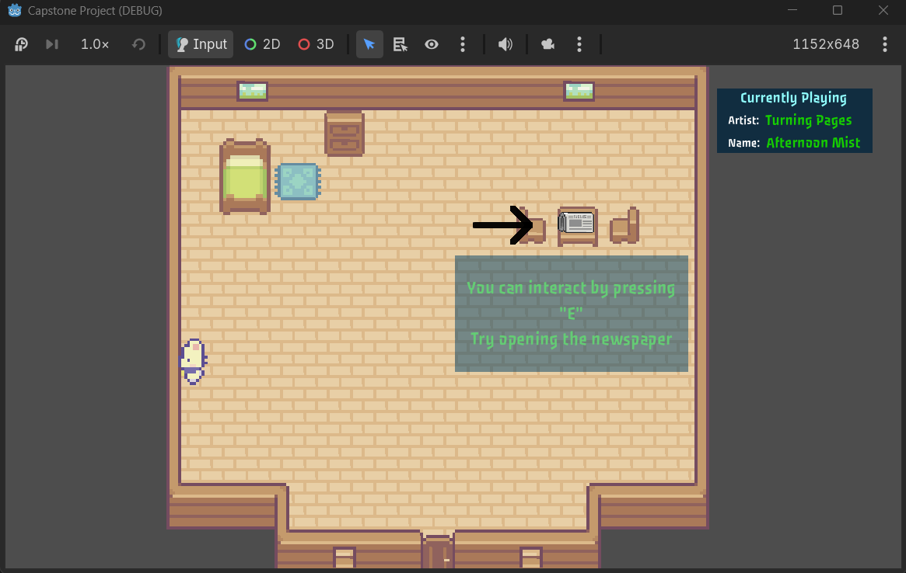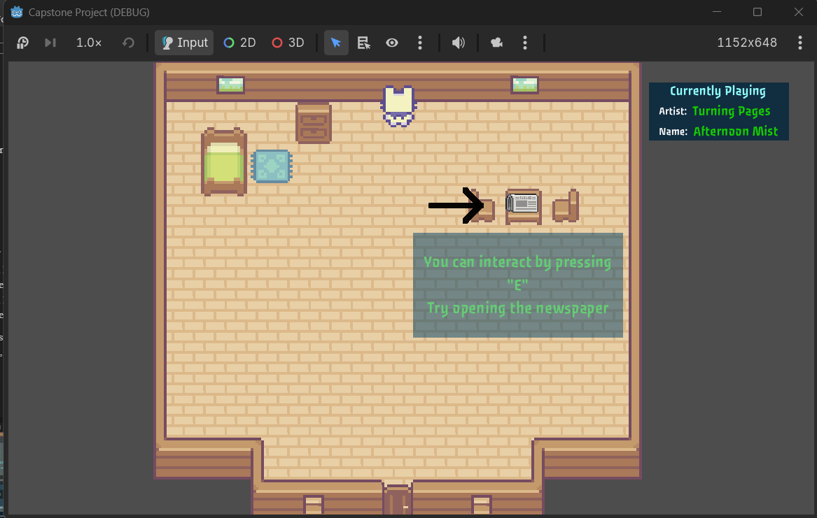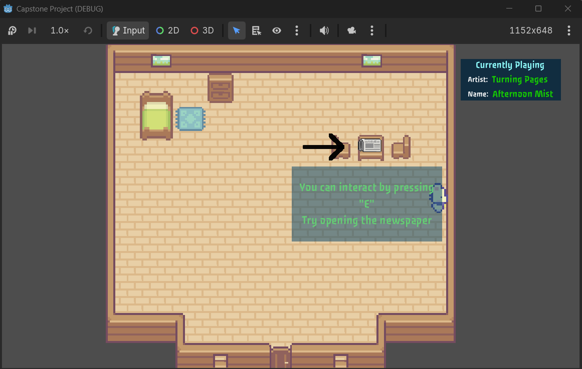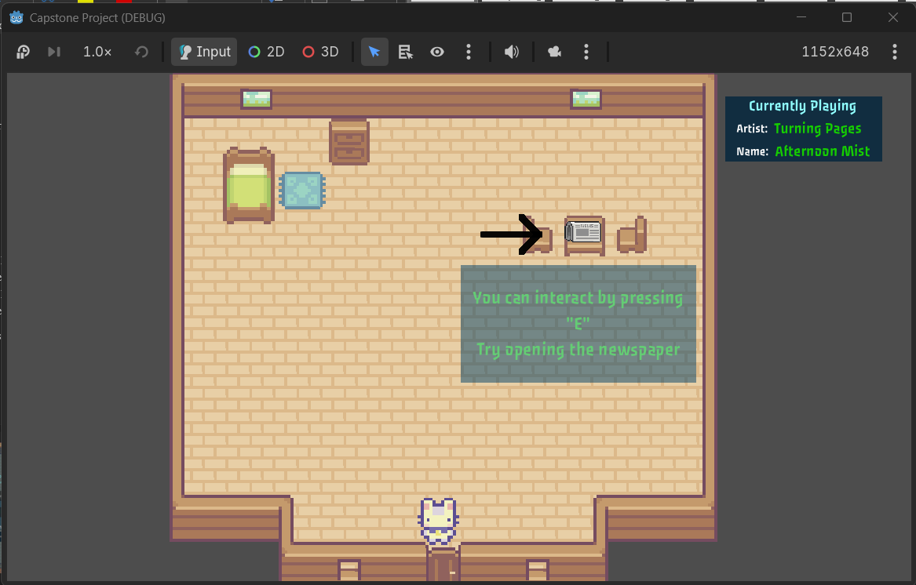
Status: Pass

Feature: Character Boundaries
Objective: Test whether character can leave the boundary of the Farm scene
Preconditions:
- DB_1 contains at least 4 ASLSigns (A,B,C,D) that are not unlocked.
TestSteps:
- Start Game
- Press the “Play” button on the main menu
- Interact with the newspaper to start ASL Learning
- Press “Done”
- Leave home using door
- Move character and attempt to leave the boundary of the Farm scene
Expected Results: character should be unable to leave boundary of Farm scene.

Actual Result:
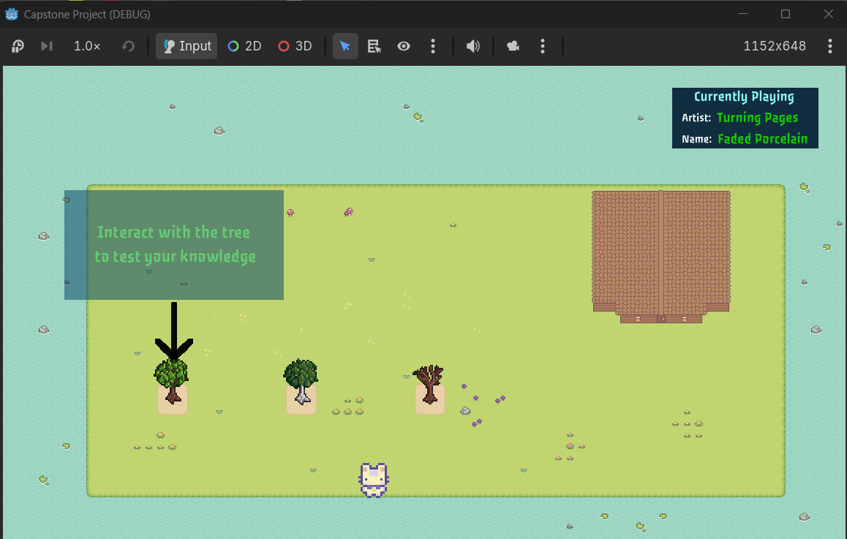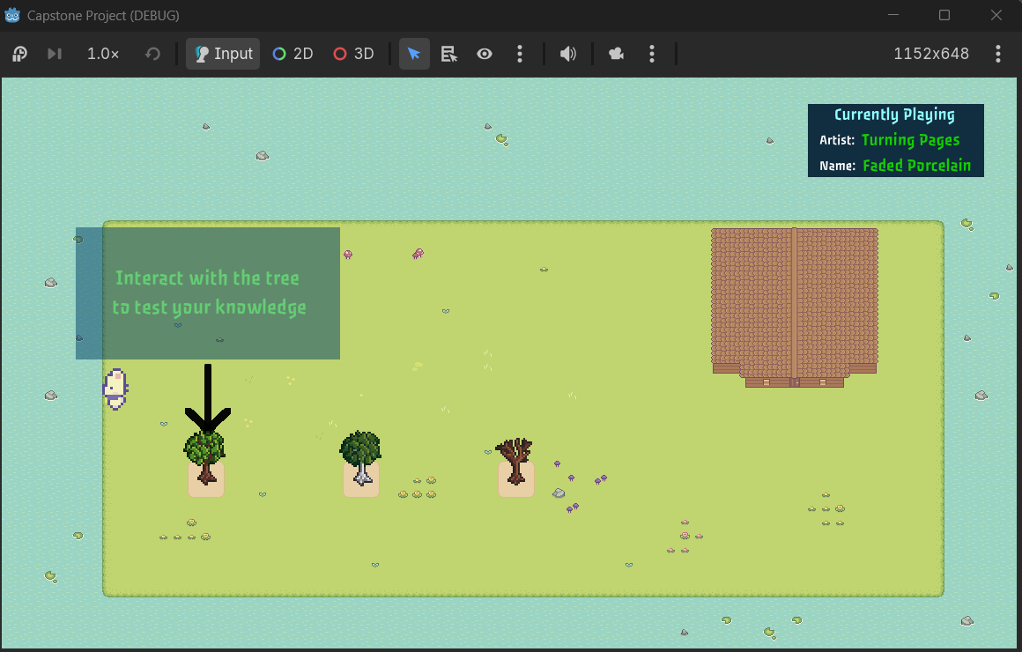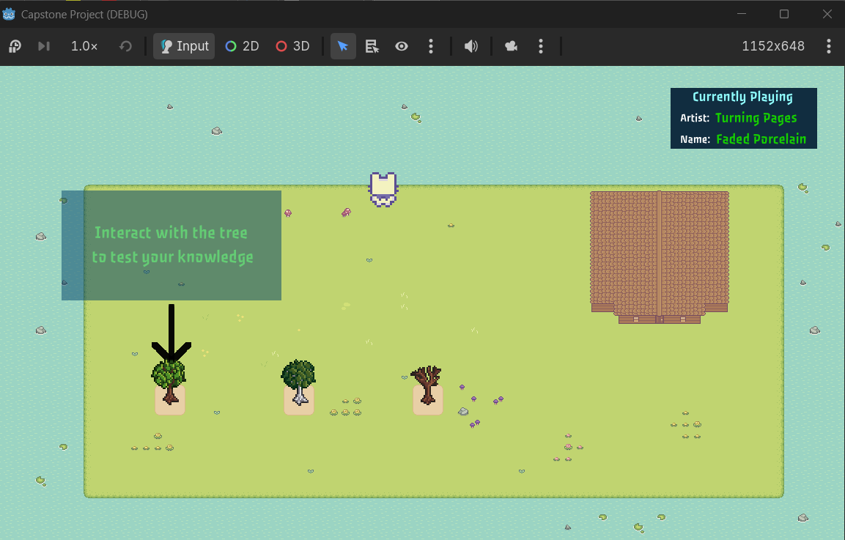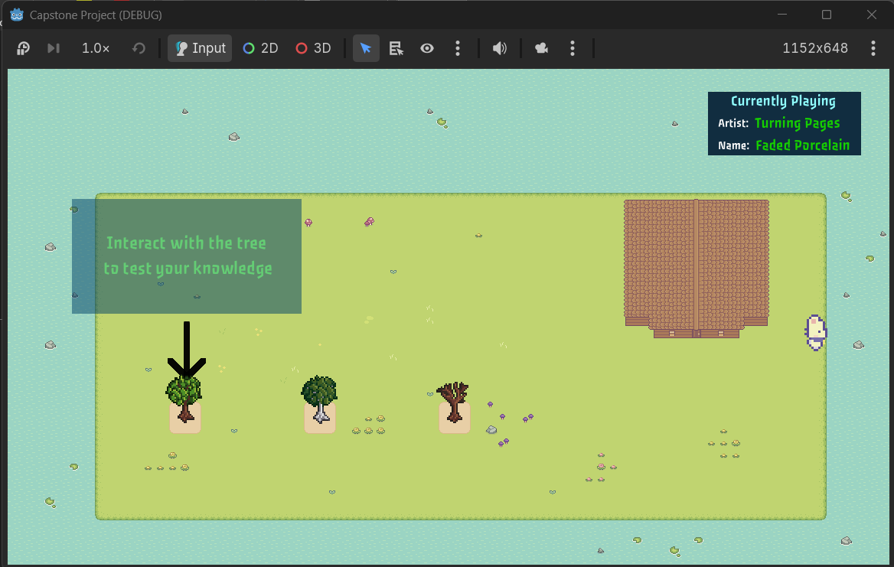
Status: Pass

Feature: Music
Objective: Test whether music cycles between all songs.
Preconditions:
- Unhandled input (Game Manager) TEST_ACTION calls TestScript.next_song()
TestSteps:
- Start Game
- Press the “Play” button on the main menu
- Note what song is currently playing.
- Press Shift+T 12 times
- Note what song is currently playing.
- Press Shift+T once more

Expected Results: Music should cycle through all other 12 songs and end up on the first song that was playing when the game first started.
Actual Result:
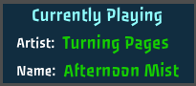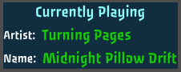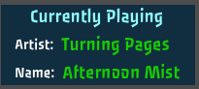
Status: Pass

Feature: Music
Objective: Test whether music is randomized
Preconditions:
- Unhandled input (Game Manager) TEST_ACTION calls TestScript.next_song()
TestSteps:
- Start Game
- Press the “Play” button on the main menu
- Note what song is currently playing.
- Press Shift+T
- Note what song is currently playing.
- Press Escape
- Click “Quit Game”
- Start Game
- Press the “Play” button on the main menu
- Note what song is currently playing.
- Press Shift+T
- Note what song is currently playing.
Expected Results: Music played on starting and order of music should be random.
Actual Result:
1st Start
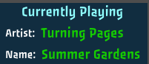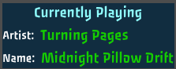
2nd Start
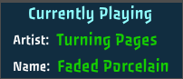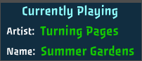
Status: Pass

Feature: Sound
Objective: Test whether sound control works on Main Menu
Preconditions:
- It is recommended to set system volume to 50%
TestSteps:
- Start Game
- Move Volume slider to the right (100%)
- Move Volume Slider to the left (0%)
Expected Results: Sound should start off moderate and increase to volume when the volume slider is moved to the 100%. Sound should be inaudible when volume slider is moved to the 0%
Actual Result:
Sound became louder when slider was moved to the right.

Sound became inaudible when slider was moved to the left.


Feature: Sound
Objective: Test whether volume slider setting is kept when transitioning from Main Menu scene to Game Manager scene and from Game Manager to Main Menu scene.
Preconditions:
- None
TestSteps:
- Start Game
- Move Volume Slider to the left (0%)
- Click “Play”
- Press Escape
- Click Main Menu
Expected Results: Sound should be inaudible when slider is moved to the left. When “Play” is clicked there should be no difference in volume and no sound should be heard. When escape is pressed the Volume slider should remain on the left. When “Main Menu” is clicked there should be no difference in volume and no sound should be heard. The volume slider should remain on the left
Actual Result: When transitioning between scenes the volume slider remained in the left position and no sound played.
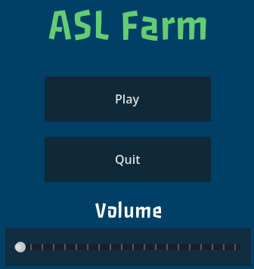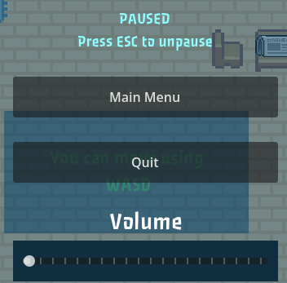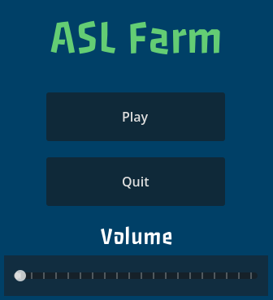
Status: Pass

Feature: Tree Growth
Objective: Test whether Trees show different sprites upon a certain number of questions being answered at a 75% correct rate.
Preconditions:
- Unhandled Input (Game Manager) TEST_ACTION calls TestScript.cycle_growth()
TestSteps:
- Start Game
- Click “Play”
- Interact with the newspaper
- Walk outside to the farm
- Walk back inside the home
- Press Shift+T
- Walk outside to the farm
- Walk back inside the home
- Press Shift+T
Expected Results: Trees should start off at level 1 growth and should advance to growth level 2 and growth level 3.
Actual Result:
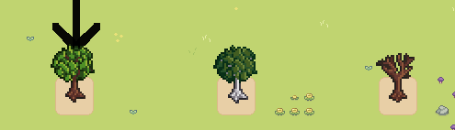
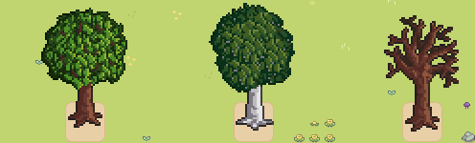
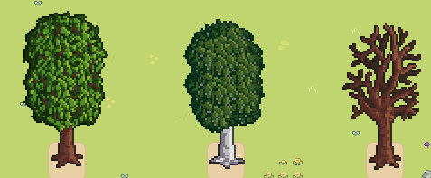
Status: Pass

Feature: ASL Quiz
Objective: Test whether Quiz indicates whether player selected the correct answer or wrong answer.
Preconditions:
- DB_1 should contain 4 signs (A,B,C,D) not unlocked
TestSteps:
- Start the game
- click “Play”
- Interact with the newspaper
- Click “Done”
- Walk to the door of the home
- Interact with far left tree
- Complete quiz tutorial by clicking one of the answer buttons
- Answer 2 quiz questions correctly and 2 quiz questions incorrectly
Expected Results: Answer button clicked should flash Green when answered correctly. Answer buttons should flash red and the correct answer button should flash green when the incorrect answer is clicked.
Actual Result:
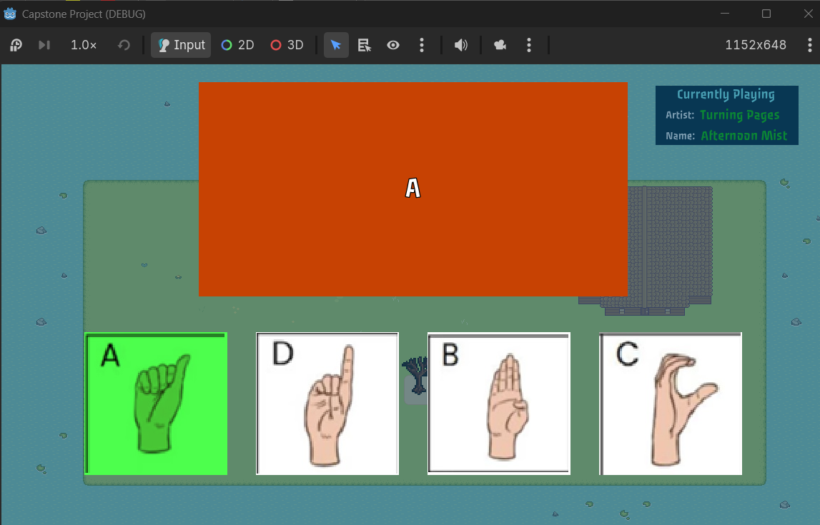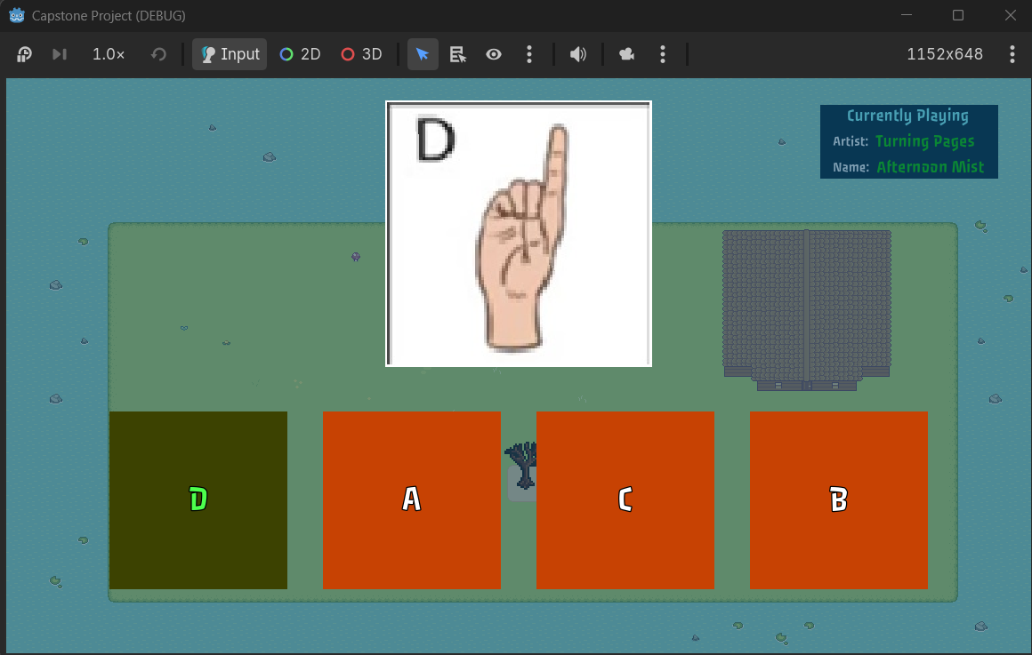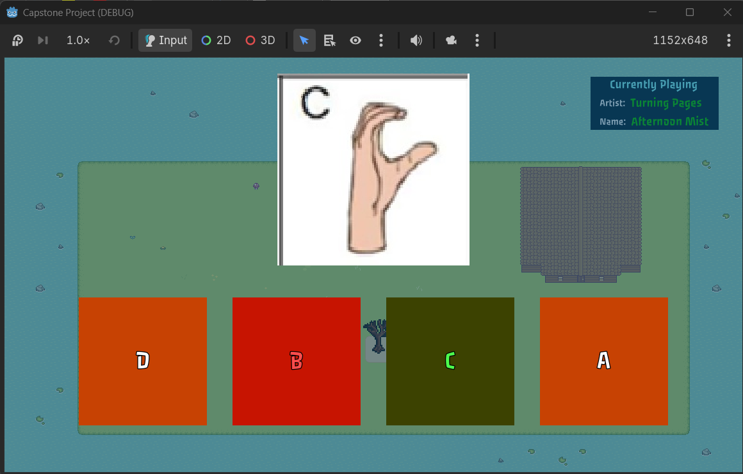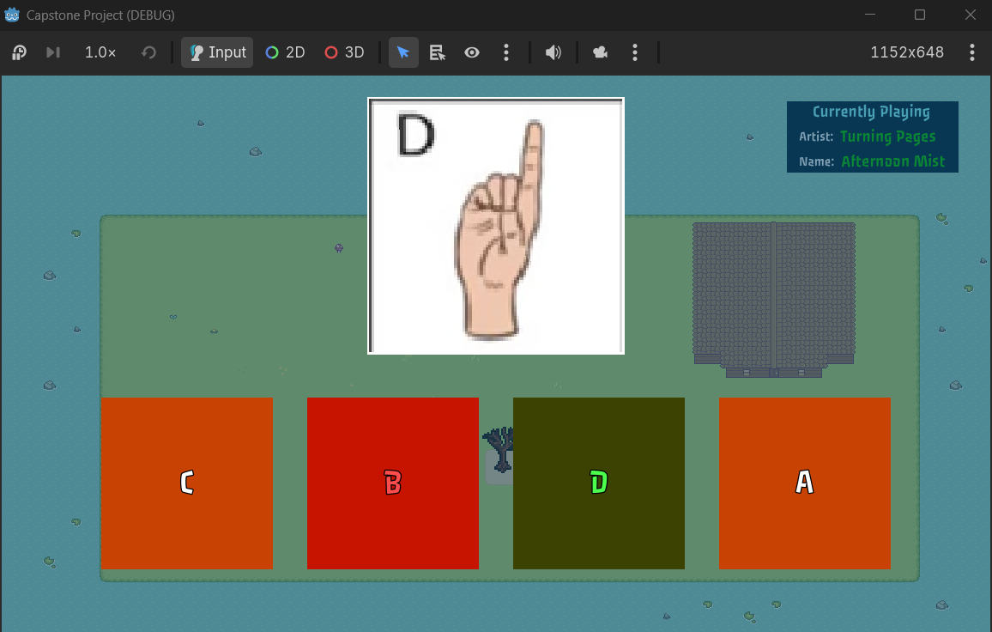
Status: Pass
Feature: Tree 2
Objective: Test whether Tree 2 is interactable when the player has learned all signs in Tree 1
Preconditions:
- Unhandled Input (Game Manager) TEST_ACTION calls TestScript.test_tree2()
TestSteps:
- Start the game
- click “Play”
- Press Shift+T
- Interact with the newspaper
- Click “Done”
- Walk to the door of the home
- Interact with the middle tree
- Click any answer button to complete quiz tutorial
Expected Results: When interacting with the newspaper an ASL Learning with ASL Signs from DB_2 should display. When interacting with Tree 3 it should display the ASL Quiz tutorial and then an ASL Quiz for DB_2.
Actual Result:
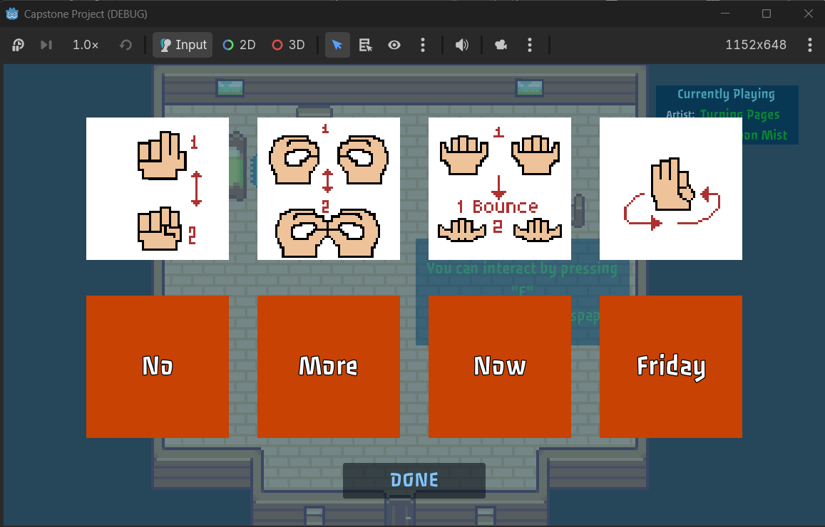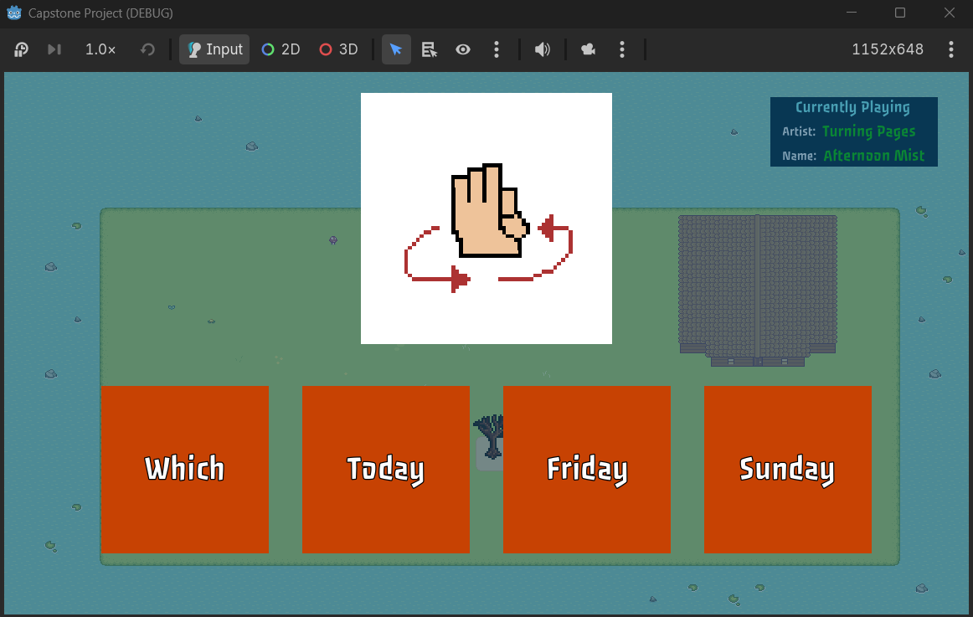
Status: Pass

Feature: Tree 3
Objective: Test whether Tree 3 is interactable when the player has learned all signs in Tree 1 and Tree 2
Preconditions:
- Unhandled Input (Game Manager) TEST_ACTION calls TestScript.test_tree3()
TestSteps:
- Start the game
- click “Play”
- Press Shift+T
- Interact with the newspaper
- Click “Done”
- Walk to the door of the home
- Interact with the right tree
- Click any answer button to complete quiz tutorial
Expected Results: When interacting with the newspaper an ASL Learning with ASL Signs from DB_3 should display. When interacting with Tree 3 it should display the ASL Quiz tutorial and then an ASL Quiz for DB_3.
Actual Result:
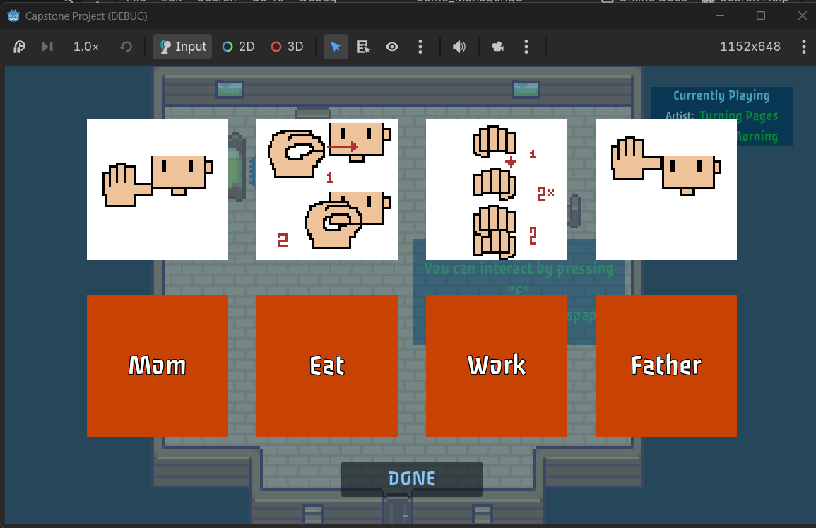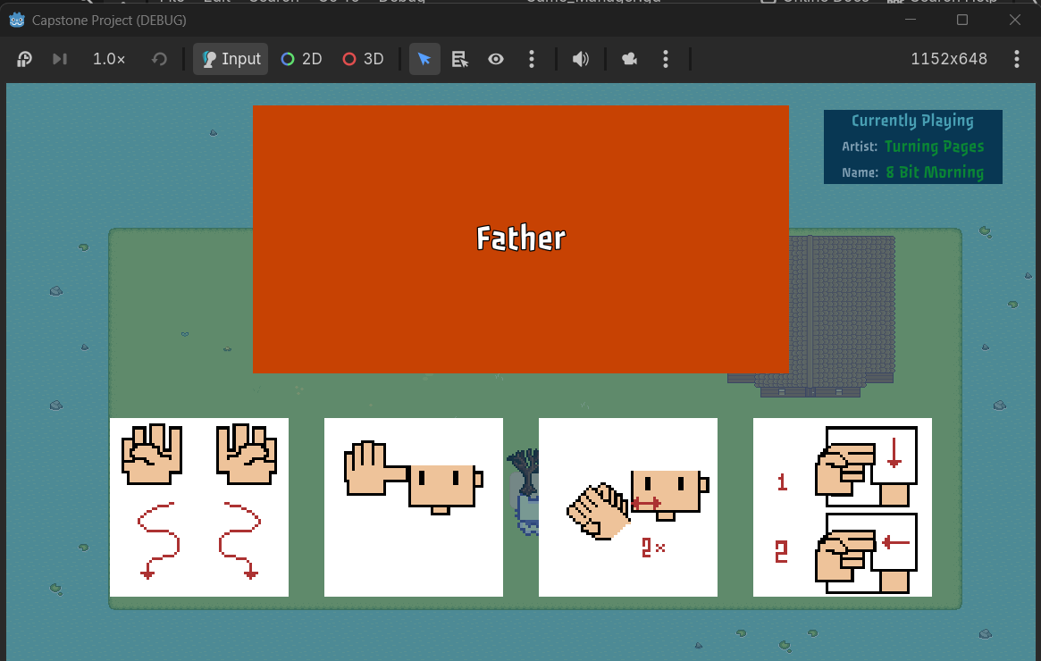
Status: Pass

Feature: Tree 1
Objective: Test whether Tree 2 and Tree 3 remain locked while DB_1 is not fully learned
Preconditions:
- None
TestSteps:
- Start the game
- click “Play”
- Interact with the newspaper
- Click “Done”
- Walk to the door of the home
- Attempt to interact with the far right tree
- Attempt to interact with the middle tree
- Attempt to interact with the far left tree
Expected Results: nothing should happen when interacting with the far right tree (Tree 3) and the middle tree (Tree 2). When the player interacts with the far left tree (Tree 1) the ASL Quiz tutorial should display
Actual Result:
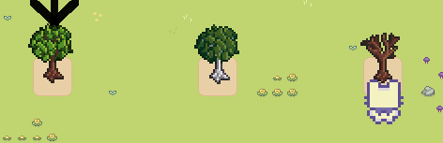
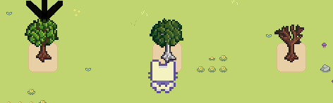
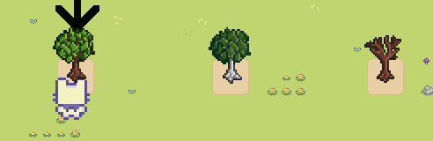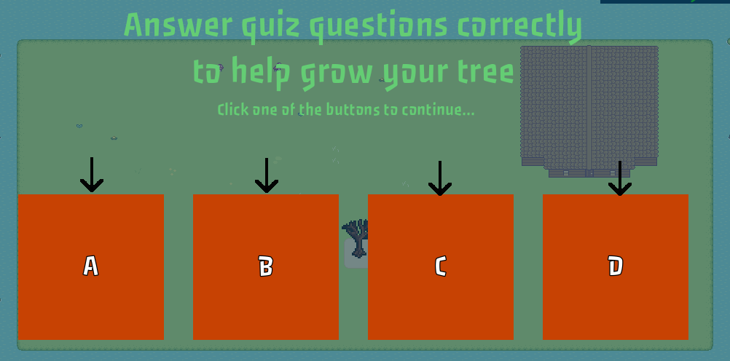
Status: Pass

Feature: Tree 2
Objective: Test whether Tree 3 remain locked while DB_2 is not fully learned
Preconditions:
- Unhandled Input (Game Manager) TEST_ACTION calls TestScript.test_tree2()
TestSteps:
- Start the game
- Click “Play”
- Press Shift+T
- Interact with the newspaper
- Click “Done”
- Walk to the door of the home
- Attempt to interact with the far right tree
- Attempt to interact with the middle tree
- Attempt to interact with the far left tree
Expected Results: nothing should happen when interacting with the far right tree (Tree 3) When the player interacts with the middle tree (Tree 2) the ASL Quiz tutorial should display.

Actual Result:
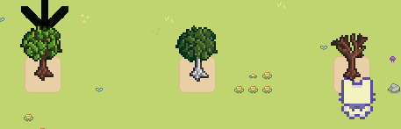
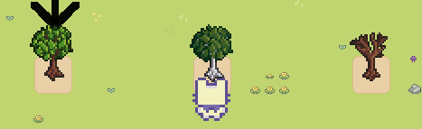
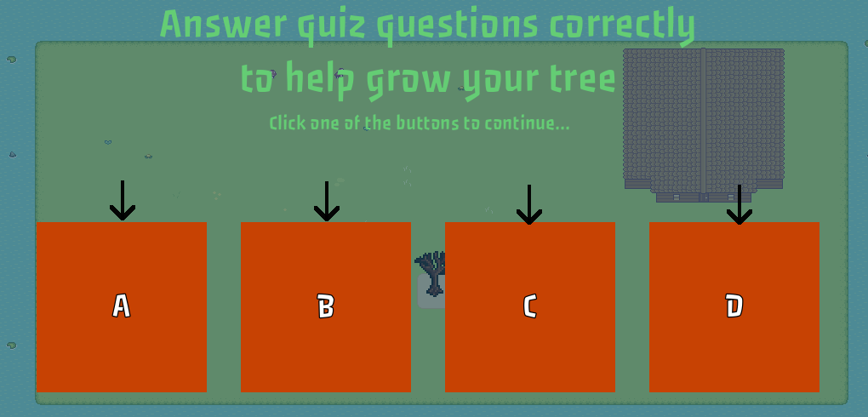
Status: Pass

